Practical 3
Aim: To implement a Word Count / Frequency Program using MapReduce in Hadoop and analyze word frequencies in a text dataset stored in HDFS.

Problem definition:
A digital publishing company stores thousands of news articles and blog posts in the Hadoop Distributed File System (HDFS). The editorial team wants to identify the most frequently used words across their content to understand trending topics and optimize content recommendations.
As a Big Data Engineer, the task is to develop a MapReduce application that processes text data and generates word frequency statistics.

Objectives:

- Configure the Hadoop environment and HDFS.
- Create and upload a text dataset to HDFS.
- Implement a Mapper to generate (word, 1) key-value pairs.
- Implement a Reducer to calculate word frequencies.
- Execute the MapReduce job on Hadoop.
- Store the output in HDFS.
- Find the top 10 most frequently occurring words.
- Analyze the performance for different dataset sizes.

Observation / Output

Step 1: Create the Input Dataset

Open the terminal and create the input file:

nano input.txt

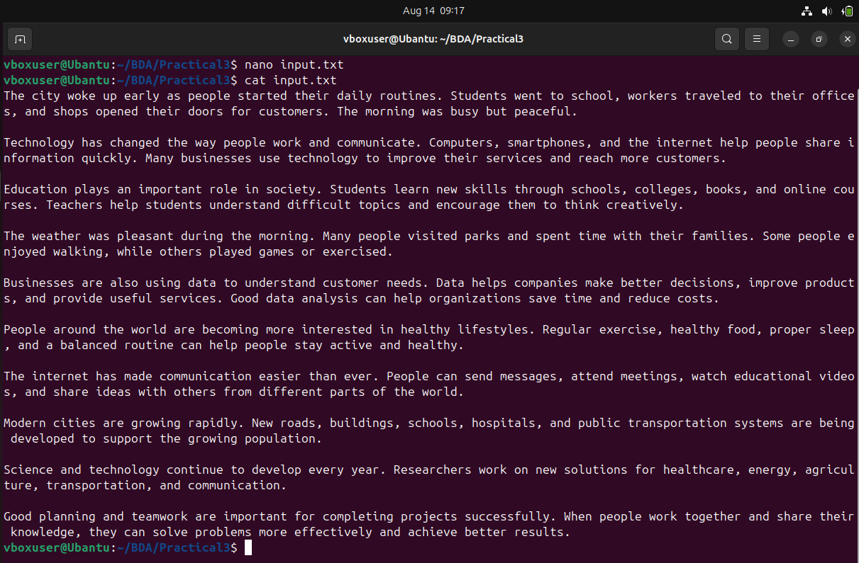
Figure 1:shows the created input.txt and its contents.

Step 2: Create the Mapper and Reducer Programs

Create the mapper file:

nano mapper.py

Create the reducer file:

nano reducer.py

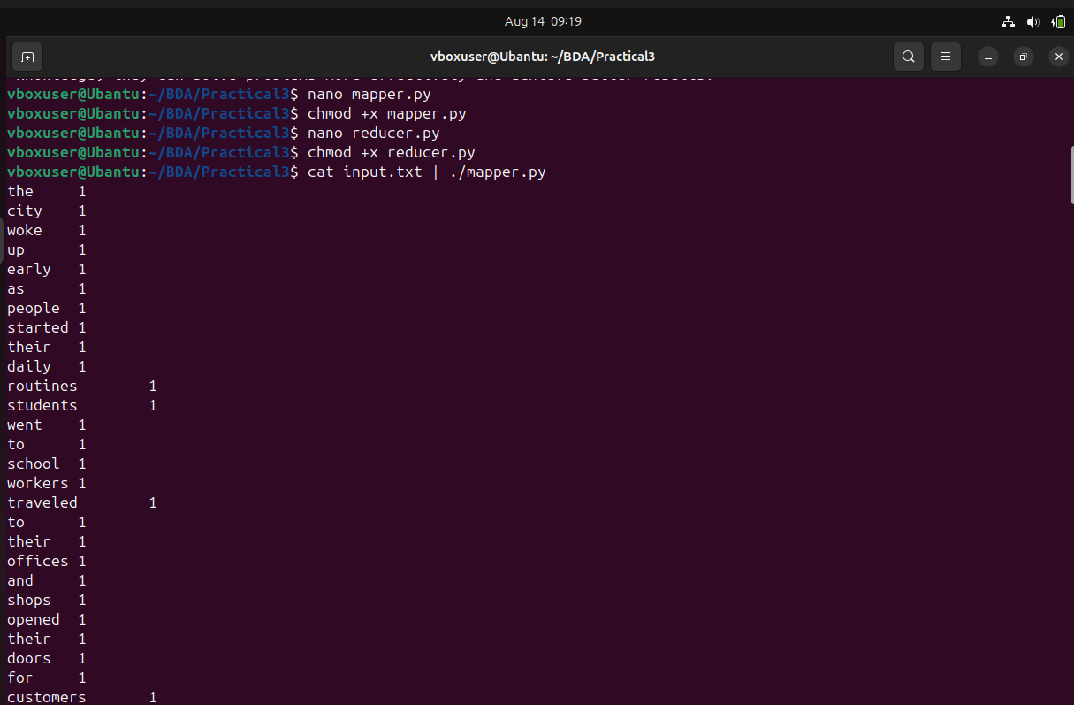
Figure 2:shows the mapper output.

Step 3: Start Hadoop Services

Start the Hadoop Distributed File System and YARN services:

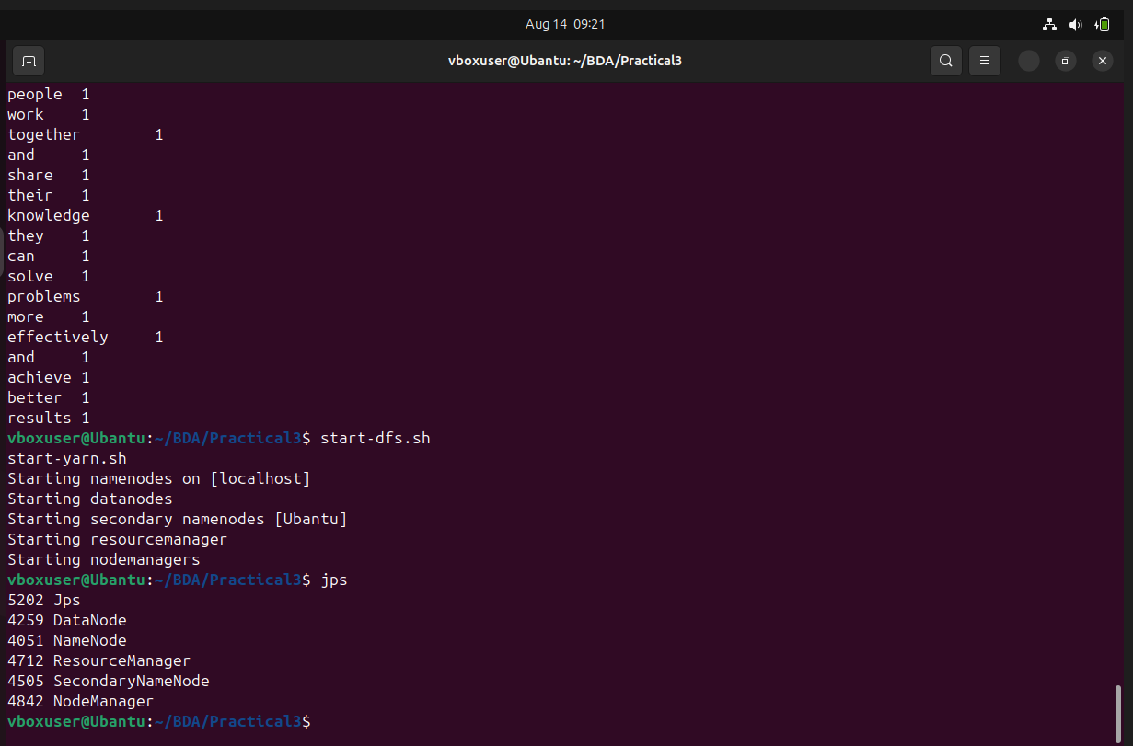
Figure 3:shows the Hadoop services being started and verified using jps.

Step 4: Create the HDFS Input Directory

Create an input directory in HDFS:

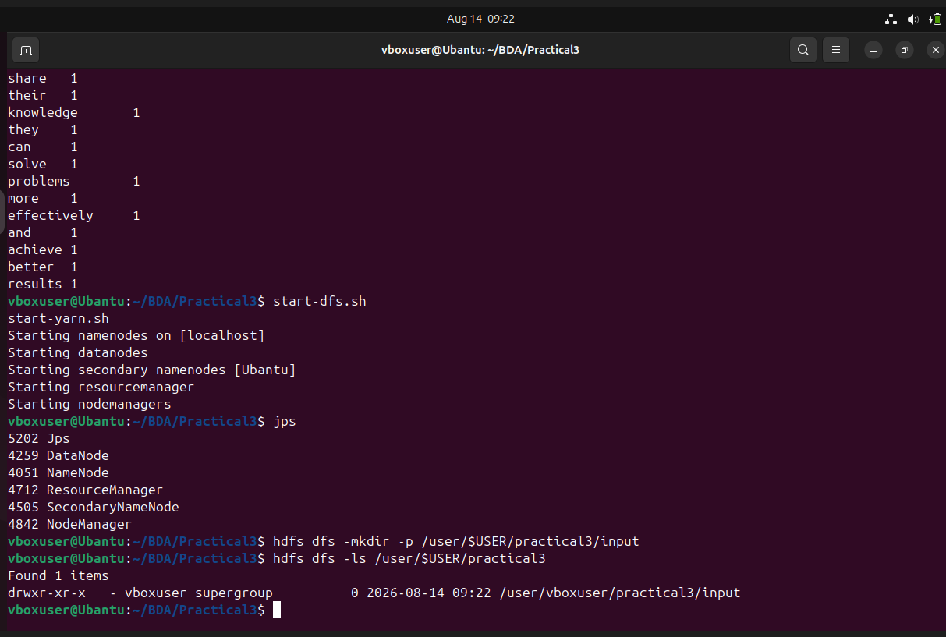
Figure 4 shows the HDFS input directory being created and checked.

Step 5: Run the Hadoop Streaming MapReduce Job

Run the MapReduce word-count job using Hadoop Streaming:

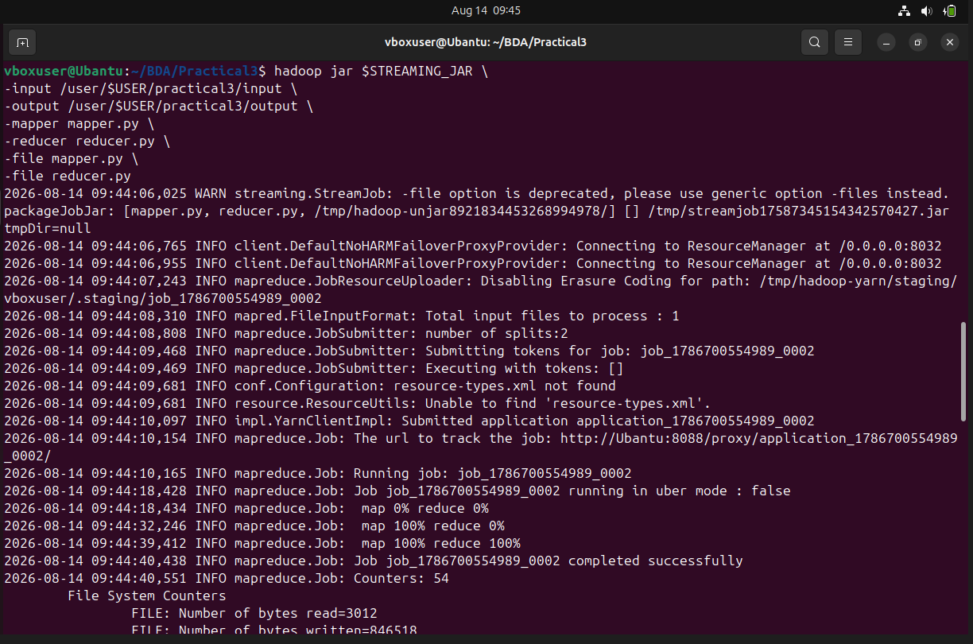
Figure5:shows the Hadoop Streaming MapReduce job running successfully.

Step 6: Check the MapReduce Output

After the job finishes, check the output directory:

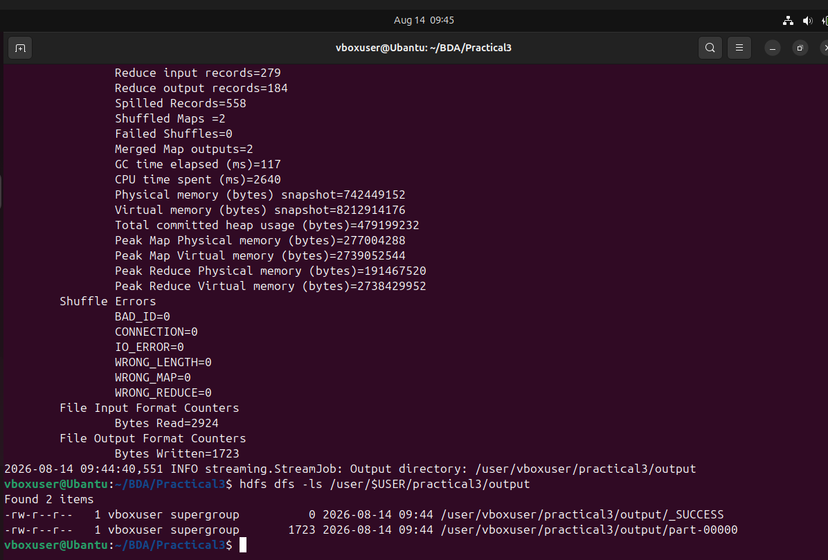
Figure 6 shows the successful MapReduce output files.

Step 7: Display the Word Count Results

Display the contents of the output file:

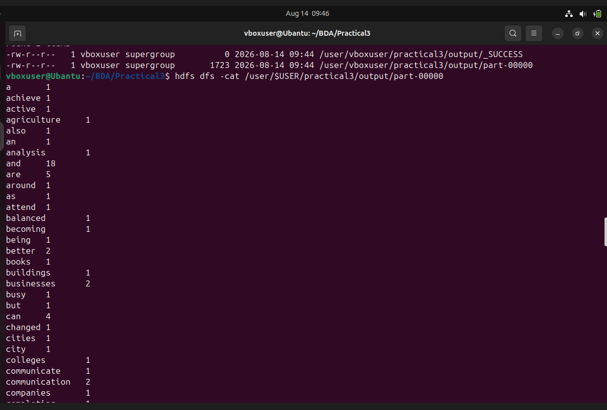
Figure 7 shows the beginning of the final word-count output.

Verify the Complete Output:

Scroll through the output to verify the remaining word frequencies.

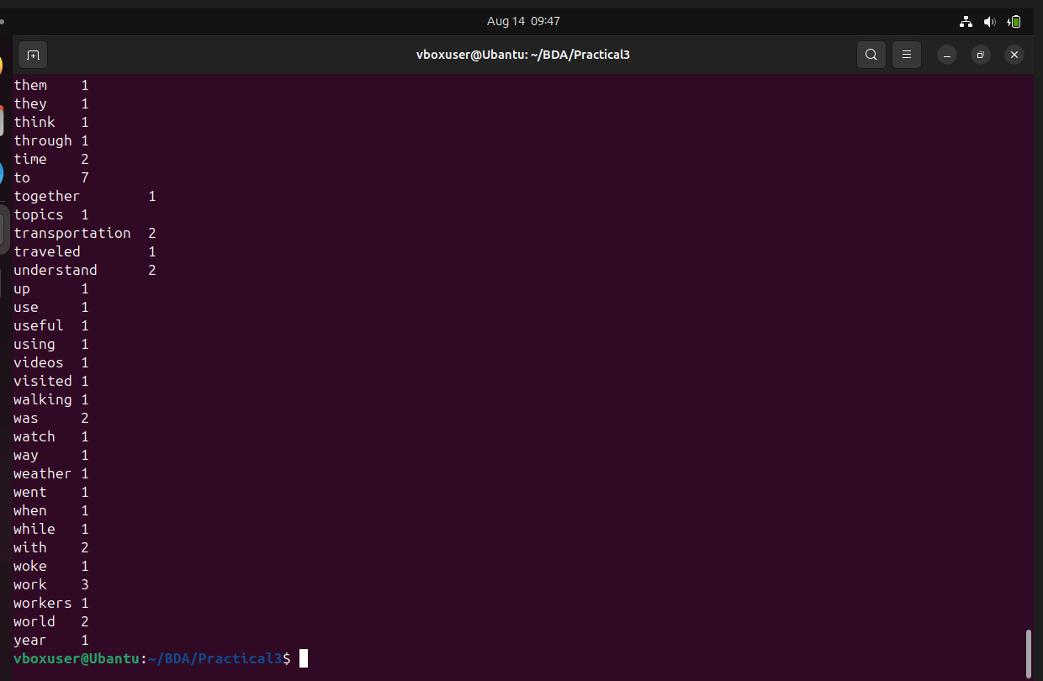
Figure 7 shows the final section of the word-count results.

Key Questions / Analysis

Q1. What is the role of Mapper and Reducer in the Word Count application?

Answer:
The Mapper reads the input data and generates intermediate key-value pairs in the form (word, 1). The Reducer receives the grouped words and adds their values to calculate the total frequency of each word.

Q2. How are intermediate key-value pairs generated and processed?

Answer:
The Mapper splits each line of text into individual words and generates (word, 1) for every word. Hadoop then performs Shuffle and Sort, which groups identical words together. The Reducer processes these groups and calculates their total frequency.

Example:

Mapper:

hello → 1

hello → 1

data → 1

Shuffle:

hello → [1,1]

data → [1]

Reducer:

hello → 2

data → 1

Q3. How does HDFS store and distribute the input dataset?

Answer:
HDFS divides large files into blocks and stores these blocks across different DataNodes. It also maintains replicas of the blocks to provide fault tolerance and reliable data storage.

Q4. What advantages does MapReduce offer for processing large datasets?

Answer:

Processes large amounts of data efficiently.

Supports parallel processing.

Provides fault tolerance.

Works with distributed storage such as HDFS.

Can scale across multiple machines.

Automatically handles tasks such as data distribution and grouping.

Q5. How does the execution time vary with dataset size?

Answer:

Generally, execution time increases as the dataset size increases. In our experiment, the large dataset took 4.364 seconds, compared with 3.363 seconds for the small dataset. The small difference between small and medium datasets is due to Hadoop's startup and job-processing overhead.

Conclusion:

The Word Count application was successfully implemented using Hadoop MapReduce. The Mapper generated intermediate (word, 1) pairs, while the Reducer calculated the total frequency of each word. The input and output data were stored in HDFS. The experiment also demonstrated the effect of dataset size on MapReduce execution time.

